**GOLDSTAR HIGH SCHOOL GANGU**

**END OF TERM THREE ASSESSMENT**

**S.1 PRINCIPLEC AND PRACTICES OF AGRICULTURE** DURATION: 2HOURS

**ANSWER ALL QUESTIONS**

**NAME……………………………………………………………………………………………………………………….**

1. In the management of their farms, farmers are encouraged to keep records. In fact, in some countries, farm records are a legal requirement for all farms. Many Ugandan farmers, however, are not in the habit of making farm records and many do not know how to properly make these records

b). Define record keeping as used in Agriculture (02marks?

………………………………………………………………………………………………………………………………………………………………………………………………………………………………………………………………………………………………………………………………………………………………………………………………………………………………………………………………………………………

(a) Suggest the potential benefits of proper record keeping to the farmers in Uganda (4 scores)

----------------------------------------------------------------------------------------------------------------------------------------------------------------------------------------------------------------------------------------------------------------------------------------------------------------------------------------------------------------------------------------------------------------------------------------------------------------------------------------------------------------------------------------------------------------------------------------------------------------------------------------------------------------------------------------------------------------------------------------------------------------------------------------------------------------------------------------------------------------------------------------------------------------------------------------------------------------------------------------------------------------------------------------------------------------------------------------------------------------

(b) outline different records kept in Agriculture? (4 scores)

----------------------------------------------------------------------------------------------------------------------------------------------------------------------------------------------------------------------------------------------------------------------------------------------------------------------------------------------------------------------------------------------------------------------------------------------------------------------------------------------------------------------------------------------------------------------------------------------------------------------------------------------------------------------------------------------

2. Early man always struggled to survive. To him it could have been the ideal life but it does not appear very interesting to some people now.

As a student of agriculture, explain the ways in which modern agriculture could be better than the means employed by early man to find food (5 scores)

……………………………………………………………………………………………………………………………………………………………………………………………………………………………………………………………………………………………………………………………………………………………………………………………………………………………………………………………………………………………………………………………………………………………………………………………………………………………………………………………………………………………………………………………………………………………………………………………………………………………………………………………………………………………………………………………………………………………………………………………………………………………………………………………………………………………………………………………………………………………………………………………………………………………………………………………………………………………………………………………………………………………………………………..………………………………………………………………………………

3. Some people claim that agriculture is the backbone of Uganda’s economy. Some claim that Uganda cannot develop if its agriculture is not well developed.

(a) Suggest the ways in which agriculture could be of value to Uganda’s economy (6 scores)

----------------------------------------------------------------------------------------------------------------------------------------------------------------------------------------------------------------------------------------------------------------------------------------------------------------------------------------------------------------------------------------------------------------------------------------------------------------------------------------------------------------------------------------------------------------------------------------------------------------------------------------------------------------------------------------------------------------------------------------------------------------------------------------------------------------------------------------------------------------------------------------------------------------------------------------------------------------------------------------------------------------------------------------------------------------------------------------------------------------

(b) What advice would you give the government of Uganda to try and improve agriculture in Uganda? (6 scores)

----------------------------------------------------------------------------------------------------------------------------------------------------------------------------------------------------------------------------------------------------------------------------------------------------------------------------------------------------------------------------------------------------------------------------------------------------------------------------------------------------------------------------------------------------------------------------------------------------------------------------------------------------------------------------------------------------------------------------------------------------------------------------------------------------------------------------------------------------------------------------------------------------------------------------------------------------------------------------------------------------------------------------------------------------------------------------------------------------------------

4. The diagrams below represent farm tools and equipment. Study them and answer

the questions follow.

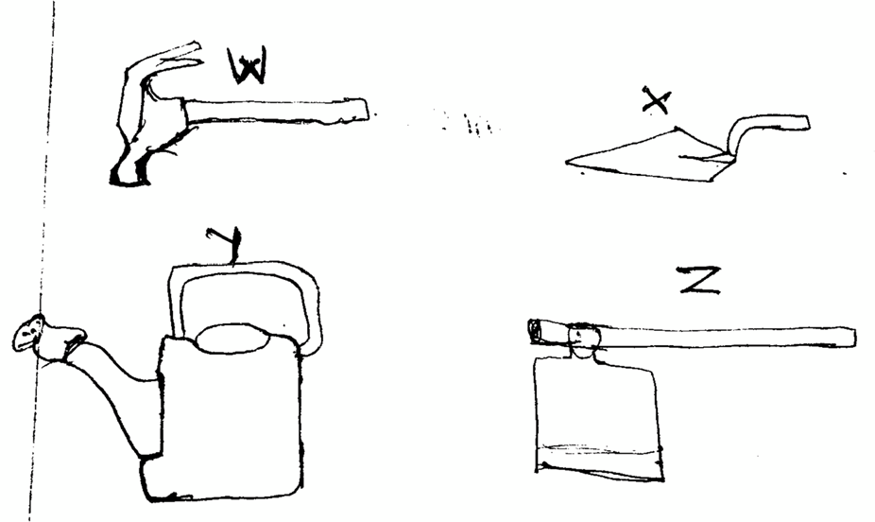

(a) Identify the tool/ equipment W, X, Y and Z (4 marks)

W ……………………………………………………………

X ……………………………………………………………...

Y ……………………………………………………………….

Z ………………………………………………………………

(b) State four uses of Z on a farm (4 marks)

………………………………………………………………………………………………………………………………………………………………………………………………………………………………………………………………………………………………………………………………………………………………………………………………………………………………………………………………………………………………………………………………………………………………………………………………………………………………………………………………..…………………………………………………

(c) Give two maintenance practices for Z on the farm. (2 marks)

…………………………………………………………………………………………………………………………………………………………………………………………………………………………………………………………………………………………………………………………………………………………………………………………………………………………………………………………………………………………………………………………………………………………………………………………………………………………………………………………………………………………………………………

5. The picture in the figure below shows the nature of some parts of Uganda. Study the photograph and attempt the activities that follows.

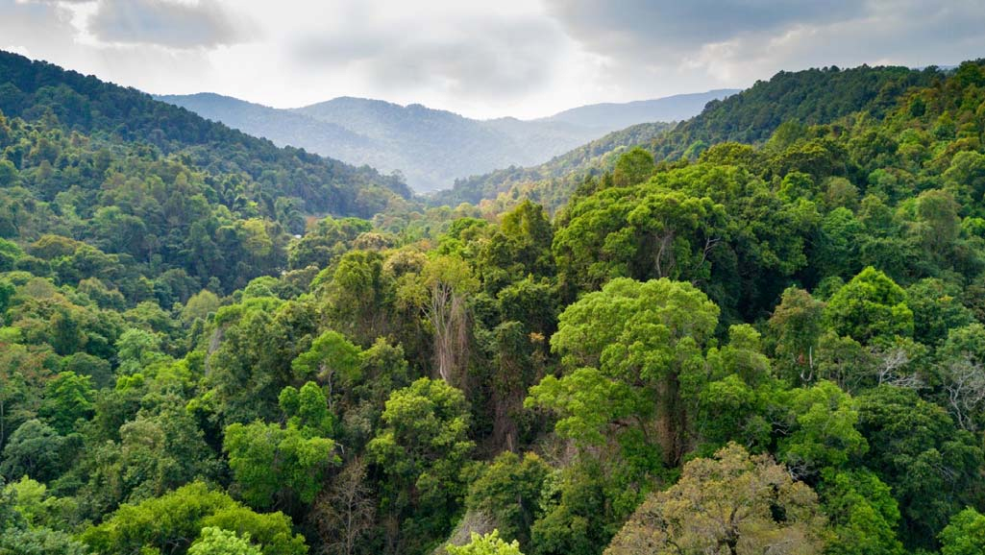

(a) As a crop scientist in that area, of what benefit is that figure to Ugandans. (4 marks)

………………………………………………………………………………………………………………………………………………………………………………………………………………………………………………………………………………………………………

…………………………………………………………………………………………………

…………………………………………………………………………………………………

(b) Point out some plant species that make up a picture above. (4 marks)

…………………………………………………………………………………………………………………………………………………………………………………………………………………………………………………………………………………………………………………………………………………………..……………………………………………

Part B (Answer all questions)

6. A farmer carried out an experiment about the average of different soil compositions and found out that amount of air = 25%, water =25%, mineral matter = 45% and organic matter 5%.

(a) Represent your calculations on the pie-chart. (08mrks)

7. Mr kato is interested in starting a crop project (vegetable growing). He is equipped with a huge piece of land which he is confused about its ability to support plant growth. As a student of S.1 who has knowledge on soil science,

a) How would he encourage the availability of soil living organisms in his field. (05mrks)

b) How would the increase of these organisms be important in the field. (05mrks)

END : MARY X-MASS AND HAPPY NEW YEAR:

END